

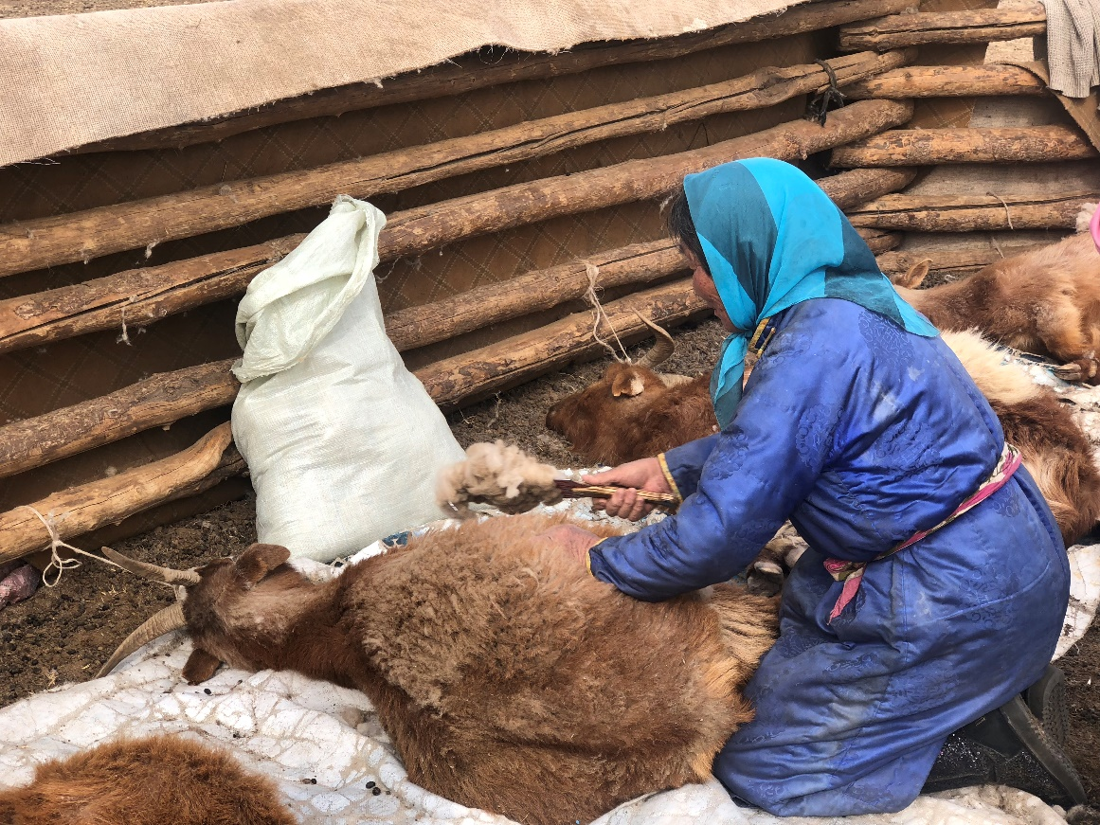

**BEHAVIOUR CHANGE RESEARCH REPORT**

A study on five key coping and risk-reducing behaviours among Mongolian nomadic herders: seasonal migration (otor), destocking, haymaking, early warning system (EWS) access and livestock vaccination

**Location**: Dornod and Sukhbaatar Aimags, Mongolia

**Date**: September, 2018

**Author**: Laurel Hanson & Dion Battersby, **PEOPLE IN NEED**

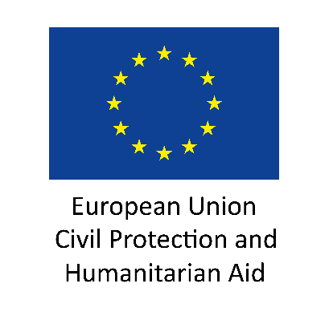



# CONTENT

CONTENT 1

SUMMARY 1

1. BACKGROUND 3

2. RESEARCH 4

2.1 Introduction 4

2.2 Training 4

2.3 Research Methodology 5

2.3.1 Questionnaire Development 5

2.3.2 Sampling Methods, Communities Visited, Dates, Teams 5

2.3.3 Coding and Data Analysis Process 6

2.3.4 Research Limitations 6

2.3.5 Lessons Learned 7

2.4 Results 9

2.4.1 Haymaking 9

2.4.2 SMS Platform Usage 11

2.4.3 Seasonal Migration 13

2.4.4 Destocking 14

2.4.5 Livestock Vaccination 15

3. FOLLOW-UP ACTIONS 18

4. ANNEXES 19

# SUMMARY

This report presents the findings of a Barrier Analysis (BA) conducted by People in Need (PIN) with support from Mercy Corps (MC) as part of the “Leveraging Technology and Tradition for Resilience in Rural Mongolia” (LTT4R) project funded by the European Union Civil Protection and Humanitarian Aid Operations (ECHO). The BA was performed to advance the consortium’s understanding of traditional and new coping mechanisms used by Mongolian nomadic herders to increase their resilience to extreme weather events. The five behaviours selected by the consortium for study were haymaking, destocking, seasonal migration (called *otor* in Mongolian), utilising an early warning system (EWS) through the project’s short message service (SMS) platform, and livestock vaccination for foot-and-mouth disease.

In Mongolia, nomadic herders face a variety of shocks and stressors including steppe fire, animal disease outbreaks, drought and an extreme weather phenomenon, known as *dzud*, which occurs in winter and causes large numbers of livestock deaths. Although herder households have well-developed traditional mechanisms to survive the harsh environment, these events are increasing in frequency and being exacerbated by factors such as overgrazing, lack of livestock regulation, and climate change. The five behaviours selected for study (outlined above) by the consortium represent both traditional and new coping mechanisms that herders can employ in order to reduce their vulnerability to shocks and stressors, and better protect their livelihoods.

The study found significant differences in survey responses between those that employ each behaviour and those who do not, described as “doers” and “non-doers” in the report. The table below provides a summary of the key differences for each group.

|  |  |  |
| --- | --- | --- |
| Behaviour | Doers | Non-Doers |
| Haymaking | Believe haymaking approved by others, improves livestock quality, is difficult to find spare parts for harvesting equipment | Believe it is difficult to make hay as available grass yields are low and access to equipment is low, making own hay ensures higher quality |
| SMS Platform Use | Believes it would be made easier with credit advance service or automatic alerts, more difficult with no credit or battery power and in remote winter camps, believe others approve and share information with neighbours, Doers also aspire to larger herds | Believe it is difficult due to Latin script, believe others disapprove of service, less likely to believe SMS service helps protect herds or improves their planning |
| Seasonal Migration | Believe migration improves livestock quality, believe local leaders and other herders approve | Believe transport is expensive, lack access to transport and other pasture areas |
| Destocking | Believe underweight livestock makes destocking difficult, and reduces livestock losses. Believe local leaders and police approve of destocking | Believe it is difficult to find and afford transport for destocking, and believe it reduces herders’ risks |
| Vaccination of Livestock | Believe easier when labour and fencing are available, believe reduces livestock losses and increases their value, more likely if vet travels to camp | Believe easier when labour and fencing are affordable, believe other herders approve, believe difficult to remember regular vaccination |

This research report advances understanding of the constraints that this population faces to performing these five behaviours, as well as factors that could motivate them to do so in the future. It is intended for use among actors in the humanitarian and development communities in Mongolia, policy makers, and the wider research community. The findings in this report will be used to better inform trainings and outreach by the LTT4R community, and to advance understanding of coping, adaptation and mitigation methods being employed by Mongolian pastoralists.

# 1. BACKGROUND

The research was implemented as a part of the project “Leveraging Technology and Tradition for Resilience in Rural Mongolia” (LTT4R) implemented by People in Need (PIN) in consortium with Mercy Corps (MC)*.* LTT4R is funded by the European Union Civil Protection and Humanitarian Aid Operations (ECHO). The project aims to strengthen the resilience of herder communities to drought, dzud and climate change. LTT4R supports good practices in household-level dzud response through on-demand weather and pasture information, the dissemination of adapted Livestock in Emergency Guidelines and Standards, delivering household preparedness and mitigation trainings, original research, and the increased capacity of national and local authorities to implement local planning and disaster risk reduction measures.

Increasingly, the livelihoods of Mongolian nomadic herders are being threatened by shocks and stressors such as steppe fire, animal disease outbreak, drought, and dzud. The dzud in Mongolia is a phenomenon characterized by a summer drought followed by a severe winter in which temperatures and/or snow make grazing inaccessible or unavailable for livestock. Although herder households have well-developed traditional mechanisms to survive the harsh environment, recent dzud events have been exacerbated by overgrazing and climate change impacts, plus political, social, economic and cultural factors, undermining coping capacity.

Under the LTT4R project, PIN and MC launched a Barrier Analysis (BA) study to better understand the constraints Mongolian nomadic pastoralists face in performing a range of coping, adaptation and mitigation measures in relation to the shocks and stressors listed above. Consultation within the consortium led to the selection of five behaviours for study: haymaking, destocking, seasonal migration (called *otor* in Mongolian), early warning system (EWS) through the project’s short message service (SMS) platform, and livestock vaccination for foot-and-mouth disease.

People in Need (PIN), an INGO based in the Czech Republic, launched programming in Mongolia in 2009 when it provided emergency assistance to herders affected by the severe winter (dzud). With the goals to save lives and protect dignity, empower people and support sustainable living, PIN established its permanent presence in Mongolia in 2011. Today, apart from providing emergency relief, PIN’s programs in Mongolia support urban sustainable development, support rural livelihoods through building the capacity of cooperatives and providing DRR and resilience programs for herders, build the capacity of civil society organizations (CSOs) and local authorities, strengthen higher education, promote environmental protection and raise awareness on air pollution. The project partner, Mercy Corps, helps people turn the crises they confront into the opportunities they deserve. Driven by local needs, their programs provide communities in the world’s toughest places with the tools and support they need to transform their own lives.

The European Union and its Member States are the world’s leading donor of humanitarian aid. Relief assistance is an expression of European solidarity with people in need all around the world. It aims to save lives, prevent and alleviate human suffering, and safeguard the integrity and human dignity of populations affected by natural disasters and man-made crises. The European Commission ensures rapid and effective delivery of EU relief assistance through its two main instruments: civil protection and humanitarian aid. Through its civil protection and humanitarian aid operations department (ECHO), the European Commission helps over 120 million victims of conflict and disasters every year. With headquarters in Brussels and a global network of field offices, the Commission’s civil protection and humanitarian aid operations department provides assistance to the most vulnerable people on the basis of humanitarian needs. For more information, please visit the European Commission’s website at <http://ec.europa.eu/echo/>.

The views expressed herein should not be taken, in any way, to reflect the official opinion of the European Union, and the European Commission is not responsible for any use that may be made of the information it contains.

# 2. RESEARCH

## 2.1 Introduction

This research was conducted to gain a deeper understanding of the factors preventing the target population from practicing promoted behaviours, and those that could motivate people to adopt these behaviours. The research will also be used to inform training and communication material promoted by the consortium, and inform future interventions. It is additionally intended for wider use among the humanitarian and development communities in Mongolia, as well as the research community. It was conducted in Dornod and Sukhbaatar Aimags among Mongolian nomadic herders dependent on livestock for their livelihood. The first two behaviours studied (SMS platform usage and haymaking) were studied in February 2018. The second two behaviours studied (destocking and seasonal migration) were studied in March 2018. The final behaviour (livestock vaccination) was studied in August 2018. These behaviours were selected as a result of consultations within the consortium on the key coping, adaptation and mitigation measures employed by Mongolian nomadic herders, following an initial desk review.

The exact behaviours studied were:

1. Haymaking: “Herders prepare sufficient hay for their animals before winter.” This was studied in Dornod Aimag.
2. SMS Platform Usage: “Herders use the SMS weather service at least weekly during winter.” This was studied in Dornod Aimag.
3. Seasonal Migration: “Mongolian pastoralists undertake otor in the fall, defined by the migration of more than 10km to a reserve pasture with ger camp and herd during the autumn season.” This was studied in Sukhbaatar Aimag.
4. Destocking: “Mongolian pastoralists whose livestock experienced drought during the summer slaughter, sell, or otherwise get rid of at least 20% of their livestock in the autumn in preparation for the winter.” This was studied in Sukhbaatar Aimag.
5. Livestock Vaccination: “With support from a veterinarian, Mongolian pastoralists vaccinate all livestock in their herd, with the exception of horses, for foot and mouth disease (FMD) twice a year as is necessary for immunization.” This was studied in Sukhbaatar Aimag.

## **2.2 Training**

A training on conducting Barrier Analysis was delivered by the PIN Resilience Advisor, Dion Battersby, in Ulaanbaatar in February 2018. Laurel Hanson (Head of Programs) and Ganchimeg Baasnajav (Project Manager) were fully trained in the methodology for a period of two days prior to launch of the survey, and developed the survey questionnaires in consultation with the trainer. A team of five additional enumerators, including one LTT4R field officer, was trained in the field by Dion. Following a pilot day, the team spent six days in the field conducting surveys for the first two behaviours, and findings were discussed before and after survey coding each evening. “A Practical Guide to Conducting a Barrier Analysis” compiled by Bonnie L. Kittle was used to design the study and teach enumerators and staff the BA methodology. This resource is available from: <https://www.behaviourchange.net/document/35-a-practical-guide-to-conducting-a-barrier-analysis>.

Prior to the study of the third, fourth and fifth behaviours, the team was given a refresher training on the methodology. Remote support was provided by Dion Battersby and Petr Schmied (PIN Lead Advisor for Strategy and Quality Development) on questionnaire development, and any issues encountered at field level.

## 2.3 Research Methodology

A Barrier Analysis (BA) study asks people a series of questions aiming to identify which barriers and motivators have the biggest influence on whether they (do not) practice the desired behaviour. The BA study uses the Doer/Non-Doer methodology that consists of interviewing 45 people who already do the behaviour (Doers) and 45 people who have not adopted the behaviour yet (Non-Doers). The differences between their answers are what matters most as they reveal the barriers and motivators to practicing the studied behaviour.

The BA methodology fits within the larger literature on Designing for Behaviour change, and asks a series of questions aimed at identifying which barriers and motivators have the biggest influence on why they do (or do not) practice a given behaviour. The difference between the Doers and Non-Doers responses reveals which barriers or motivators are for them the most important determinants. The focus of the BA is on the way people *perceive* their abilities or constraints, irrespective of what the survey team believes to be the available resources and capacities.

The BA methodology was adapted to assess 11 of the 12 determinants listed in the Practical Guide, as illustrated on page 8. These 12 key determinants (perceived self-efficacy, perceived positive consequences, perceived negative consequences, perceived social norms, access, cues for action, perceived susceptibility, perceived severity, perceived action efficacy, perceived divine will, policy, and culture) are categories of reasons why the group studied may or may not practice a given behaviour. The formative research summarized in this study identified the most significant reasons why the priority group was not practicing the behaviour, as well as the enablers that facilitate adoption of the behaviour. After consultations with the Project Manager, “perceived divine will” was removed from the determinants studied as it was determined that it was not relevant to the selected behaviours in the Mongolian context.

### 2.3.1 Questionnaire Development

Following the training of the Mongolia team, English language questionnaires were developed in workshop sessions ensuring consistency of approach and clarity. The questionnaire template uses forms of hypothetical questions construction that are not often used in many languages. Therefore, the questionnaires were first translated into Mongolian by the Project Manager, then reviewed and edited by another native Mongolian speaker colleague from outside the team.

### 2.3.2 Sampling Methods, Communities Visited, Dates, Teams

For the performance of the first two questionnaires (haymaking and SMS platform usage), local authorities in Dornod Aimag were informed that the research team would be coming to the area, and asked to invite herders from their current homes to their Soum (administrative unit smaller than an Aimag) centre. This approach was used as traveling to individual homes was impossible for the research team, due to the large geographic spread of the population in rural Mongolia. For their participation in the BA, herders were given coffee, tea, snacks, cell phone and vehicle fuel vouchers. This was to compensate for the costs associated with travel and participation. The surveys were conducted in Government buildings in Bayantumen, Choibalsan, Tsagaan Ovoo and Bayandun Soums of Dornod Aimag from the period of February 22-28, 2018. Enumerators for this portion of the BA were Ganchimeg Baasanjav (PIN), Enkhtuvshin Altangerel (PIN), Erdenebileg Ulgiit (MC), Tumenbayar Purev, Ganbat Amarbayan and Ganzorig Batdorj. The survey and coding were supervised by Dion Battersby and Laurel Hanson, and translation was performed by Ganchimeg Baasanjav.

The second two questionnaires (seasonal migration and destocking) were performed while the team was also performing an emergency response distribution in Sukhbaatar Aimag. Distributions were performed in the Soum centre, and Soums involved in this portion of the BA were Sukhbaatar, Khalzan, Asgat, Erdenetsaagan, Dariganga, Naran, Ongon and Uulbayan. The survey team accompanied the distribution team, and surveyed herders who were waiting to receive an emergency livestock feed kit or those who were waiting outside the distribution centre. Where possible the survey team also went into the local market to survey herders buying supplies there. This was conducted during the period between March 21 and 28, 2018. Enumerators for this portion of the BA were Erdenebileg Ulgiit (MC), Tumenbayar Purev, Dorjkhand Vaamba and Ganbat Amarbayan. The survey and coding were supervised by Laurel Hanson, Ganchimeg Baasanjav, Enkhtuvshin Altangerel (PIN) and Ganbold Zorigtbaatar (PIN).

The final barrier analysis related to vaccination practices was conducted in the local Government office of Tsagaan Ovoo, Dornod province, in August, 2018. The location was selected as a target Soum of the LTT4R programme, where PIN has established strong relations with local authorities and the herder community. Enumerators for this portion of the BA were Enkhtuvshin Altangerel (PIN), Erdenebileg Ulgiit (MC), Tumenbayar Purev, Dorjkhand Vaamba and Ganbat Amarbayan. The survey and coding were supervised by Ganchimeg Baasanjav and Enkhtuvshin Altangerel (PIN).

### 2.3.3 Coding and Data Analysis Process

Coding was performed by the team on the same day as the surveys were conducted, to ensure recollection of unclear answers. The original hard copies of individual surveys were distributed to the same enumerators who had completed them. The coding process was led for the first two questionnaires by Dion Battersby and Laurel Hanson, with translation performed by Ganchimeg Baasanjav. For the second two questionnaires, coding was led by Laurel Hanson with translation from Ganchimeg Baasanjav. For the final questionnaire, the coding process was led by Ganchimeg Baasanjav and then analysis of the coded data was conducted together with Laurel Hanson.

During each coding process, responses from different interviewees were checked for similarity. After team discussion, responses were grouped into categories based on the similarity and spirit of the response, as determined by the enumerators. Once the responses and categories had been clearly defined, and the managers leading the coding process had ensured full comprehension and agreement of the team, enumerators were asked which of their surveys met the defined categories, in terms of both doers and non-doers. Responses were then recorded into an excel sheet; see the Annexes of this report. The numbers of responses in each category then led to the calculation of the statistical relevance of each determinant.

### 2.3.4 Research Limitations

The study was constrained by the dispersed nature of Mongolian herder populations. Participants in some cases were drawn from those herders that responded to invitations from PIN, disseminated via the local authorities. This may have led to an over-representation of herders with stronger links to the local officials, more well-off herders who had available fuel for the long journey, or perhaps less well-off herders who attended in return for vouchers.

For other behaviours, participants were invited from herder recipients of emergency assistance provided through a concurrent PIN project or from communities that had strong existing relations with PIN. This may have affected some respondents’ answers, through social desirability bias. In order to mitigate these limitations, random sampling was used to the extent possible. In addition, enumerators were recruited from outside the PIN teams providing aid, and received training on how to encourage honest and unbiased responses.

### 2.3.5 Lessons Learned

The study found that enumerators and respondents both required additional explanations related to the hypothetical construction of some questions, and this may have affected the pilot survey results. However, this issue was addressed during advisor feedback sessions and is not believed to have impacted on the overall findings. In addition:

* Herders often lived more than 10km from their closest neighbours, so it was not viable to conduct random household sampling.
* Responses regarding community approval or disapproval were limited by the fact that people were brioken down into two groups of known “neighbours” - whatever the geographical distance - and “People I do not know”.
* It was discovered towards the end of the survey that the Northern survey region had unusually high yields of grass and even donated surplus hay to other Aimags, potentially distorting the overall results.

Separate to the barrier Analysis, the research team expected to see that use of the SMS Platform was highly correlated with delivery of LTT4R project materials and information campaigns. However, in some cases high user numbers were found in soums that had not yet been targeted by the campaign. Further investigation found that highly engaged soum and bagh (the next smallest administrative unit) leaders were able to successfully promote the SMS service in their communities, prior to project aware raising actions. This information was used to improve later delivery of project activities, by strengthening attention on local leaders in addition to direct marketing campaigns.

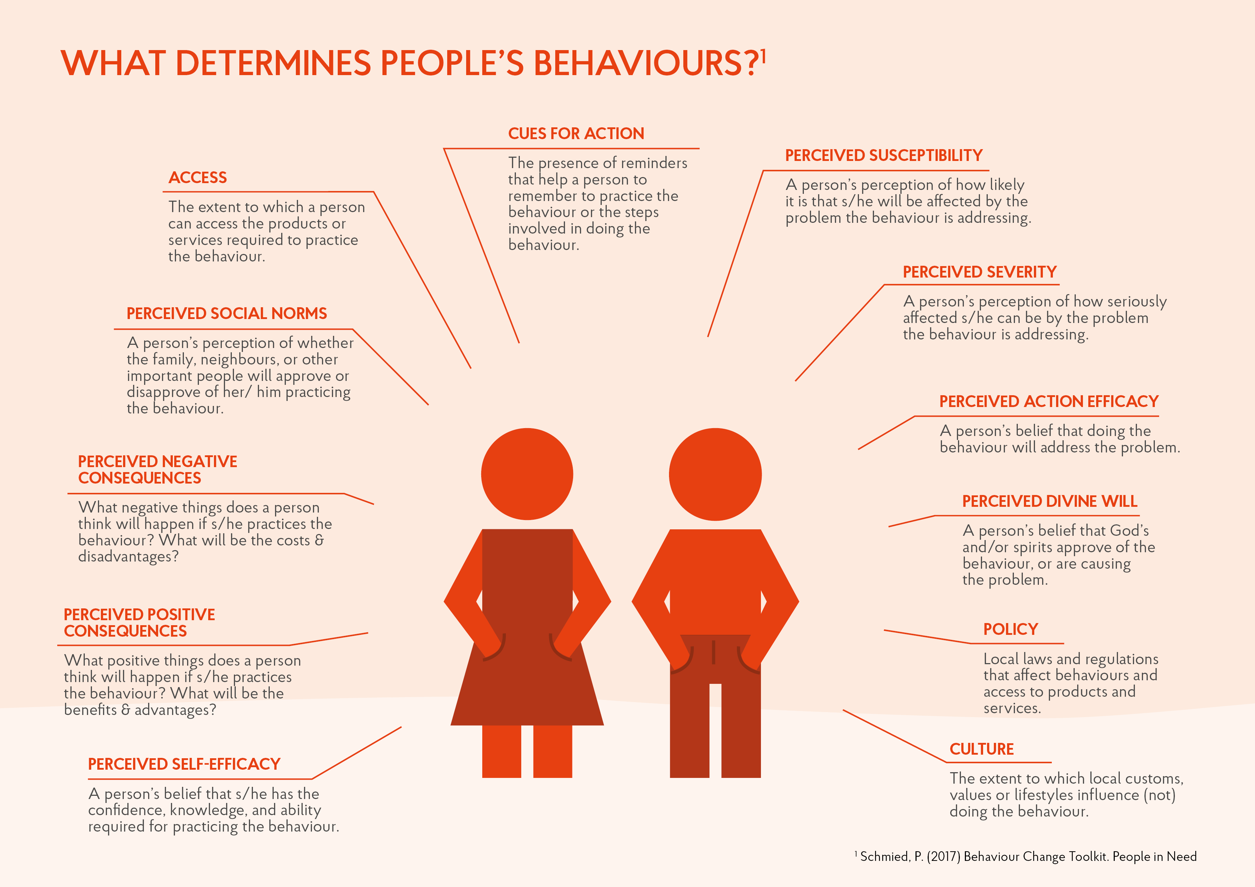

## 2.4 Results

This section highlights the key findings from each study, together with analysis using the Designing for Behaviour Change (DBC) Framework. The Bridges to Action and Activities have been compiled from the results of staff workshops and suggestions from the lead facilitators. Progress and outcome indicators have been proposed without a fixed timeframe, as suggested activities are anticipated to be carried out in future projects. Complete results for all questionnaires can be found in the BA Tabulation Sheets in the annexes. Only the most **significant differences** between Doers and Non-Doers (≥15 percentage points and p-value <0.05) were used.

### 2.4.1 Haymaking

|  |  |  |  |  |
| --- | --- | --- | --- | --- |
| **THE DESIGNING FOR BEHAVIOUR CHANGE (DBC) FRAMEWORK** | | | | |
| **Behaviour** | **Priority & Influencing Groups** | **Determinants** | **Bridges to Activities** | **Activities** |
| **Herders prepare sufficient hay for their animals before winter**  *(Addresses: Winter feed shortages and malnourished animals)* | **Priority Group:**   * Male and female herders aged 18-65 years owning livestock in Dornod Province * Herders who want to reduce animal mortality   **Influencing Groups:**   * Neighbours positively influence this behaviour * No significant influencing groups are opposing this behaviour | **Self-Efficacy:**   * Herders say a shortage of equipment spare parts makes it difficult * Herders say low grass yields make it difficult * Herders say having no haymaking equipment makes it difficult * Herders say preparing hay as a community makes it easier * Herders say good quality equipment makes it easier   **Consequences:**   * Making hay saves money * Guarantees good quality hay * Making hay increases livestock productivity * Making hay takes up a lot of time   **Culture:**   * Haymakers say their neighbours approve * Herders want to increase the size of their herd * Herders would like to start dairy businesses   **Access:**   * Non-Doers find it generally very difficult to make hay   Efficacy:   * Herders say if you prepare hay you are unlikely to lose livestock | * Increased access and availability of haymaking materials and equipment * Strengthened perception that haymaking supports larger herds, therefore higher incomes * Strengthened perception that haymaking is easier and quicker when done jointly * Strengthened perception that haymaking reduces expenses, therefore higher incomes * Strengthened perception that haymaking increases productivity of livestock, , therefore greater dairy opportunities and incomes | **Herders:**   * Promote sharing of haymaking equipment, labour, and transportation * Provide grants for haymaking rental equipment to herder cooperatives * Peer-to-peer trainings on benefits of haymaking e.g. increased herd size, reduced expenditure, increased dairy production * Conduct dairy value chain analysis to identify barriers and opportunities in target soums   **Local Authorities:**   * Build capacity for LAs in sustainable pasture management and monitoring of haymaking areas * Advocate for community haymaking areas, with secure storage and shared transportation |
| **Outcome Indicators**:   * 400 households begin or increase haymaking by end of 2021 across 27 soums of Dornod and Sukhbaatar aimags * Communal pasture management is included in 27 Soum development plans by end of 2021 across Dornod and Sukhbaatar aimags * 27 new cooperatives (1 per target soum) have been established and functioning by end of 2021 | | | **Process Indicators**:   * 2 x haymaking peer trainings facilitated in 27 soums (54 total) by end of 2021 * 10 x pasture management and community haymaking workshops held for soum and bagh leaders by end of 2021 * 4 x cooperative establishment and management workshops organised for herders in 27 soums (108 total) by end of 2021 | |

### 2.4.2 SMS Platform Usage

|  |  |  |  |  |
| --- | --- | --- | --- | --- |
| **THE DESIGNING FOR BEHAVIOUR CHANGE (DBC) FRAMEWORK** | | | | |
| **Behaviour** | **Priority & Influencing Groups** | **Determinants** | **Bridges to Activities** | **Activities** |
| **Herders use the SMS weather service at least weekly during winter**  *(Addresses: Risks associated with movements and reduced pasture in bad weather)* | Priority Group:   * Male and female herders and assistant herders aged 18-65 years in Dornod Province * Herders who want to reduce animal mortality * Herders who want to avoid dangerous conditions   Influencing Groups:   * No significant influencing groups are opposing this behaviour | Self-efficacy:   * Herders say a contract for regular SMS delivery would make it easier * Herders say a “credit advance” system for mobile fees would make it easier * No mobile credit makes it difficult to use the service * No battery charge makes it difficult to use the service * Low/no network coverage in winter camps makes it difficult to use the servoce * Latin script SMS makes it difficult to utilise the service   Consequences:   * Herders say using SMS service protects from natural risk * SMS improves herder planning * SMS info can be shared with neighbours   Culture & Norms:   * SMS improves herder planning * Non-doers think people do not approve of SMS service | * Service providers are able to provide various payment and SMS delivery contracts * Increased household access to charged batteries * Service providers provide greater geographical mobile coverage * SMS are provided in Cyrillic script * Herders are aware of benefits of using SMS Weather Service | Herders:   * Promote keeping a second chrged battery available in Household DRR Workshops * Provide project-branded power banks in workshops, that double up as visibility * Improve SMS promotional materials and info sharing within project trainings, highlighting the demonstrated positive consequences for other herders   NEMA:   * Hold discussions with NEMA on widening delivery and payment options for the service after handover * Promote the use of SMS service to NEMA in technical assistance and handover discussions * Advocate for SMS service to be delivered in Cyrillic script after handover * Advocate for SMS-based advertising and registration system to reach remote herders   Mobile Service Providers:   * Lobby for special group deals for members of Cooperatives or Herder Associations * Advocate for SMS service to be delivered in Cyrillic script |
| **Outcome Indicators**:   * 5,000 new SMS users are registered and using the service by end of 2019, against 2017 baseline * SMS service delivered in Cyrillic script by end of 2019 * NEMA staff express confidence in management and further roll out of SMS service by end of June 2019 | | | **Process Indicators**:   * Improved SMS service promotion campaign is launched across all target regions by end of 2019 * PIN & MC hold advocacy meeting with NEMA and service provider to change SMS script by June 2019 * At least 5 handover and technical assistance meeting held with NEMA and Mercy Corps by end of June 2019 | |

### 2.4.3 Seasonal Migration

|  |  |  |  |  |
| --- | --- | --- | --- | --- |
| **THE DESIGNING FOR BEHAVIOUR CHANGE (DBC) FRAMEWORK** | | | | |
| **Behaviour** | **Priority & Influencing Groups** | **Determinants** | **Bridges to Activities** | **Activities** |
| “Mongolian pastoralists undertake otor in the fall, defined by the migration of more than 10km to a reserve pasture with ger camp and herd during the autumn season.” This was studied in Sukhbaatar Aimag. | **Priority Group:**   * Herders in Sukhbaatar province   **Influencing Groups:**   * Local authorities * Neighbouring herders | Self-efficacy:   * It is difficult to migrate without transport * It is difficult for Non-doers to afford transport   Consequences:   * Doers strongly believe animals gain weight with Otor   Social Norms:   * Doers strongly believe neighbours and the Bagh Governor approve of Otor   Access:   * It is very difficult for Non-doers to access transport * Non-doers find it difficult to identify Otor locations | * Increase the consideration of traditional transportation e.g. camels and oxen carts * Promote cooperative migration between poorer and wealthier herders * Increased dairy production and marketing for higher incomes * Raised awareness of improved animal condition with migration * Improved pasture management and optimal utilisation | Herders:   * Awareness raising activities:   + Benefits of using traditional transportation   + Cooperation with other herders to reduce costs * Dairy market development:   + Training for herders on dairy products   + Introduce new technology   + Exchange and study visits with experienced women dairy producers in Arkhangai * Build financial literacy:   + Support on household budgeting and savings   + Product marketing and profitability * Encourage cooperation:   + Promote formal and non-formal cooperatives of herders   Local Authorities:   * Awareness raising activities:   + - Benefits of Otor for citizens     - How to support citizens     - Build relationships between host and origin Soums/Baghs * Support authorities in sustainable pasture management:   + - Policy development     - Migration management     - Conflict management       * Long term equity of access |
| **Outcome Indicators**:   * 500 households begin producing dairy products for market by end of 2021 across 27 soums of Dornod and Sukhbaatar aimags * 940 herders demonstrate improved knowledge of household economic management by end of 2021 * 27 new cooperatives (1 per target soum) have been established and functioning by end of 2021 * 27 Soum Leaders report increased rates of otor against 2018 baseline by end 2021. | | | **Process Indicators**:   * 6 x dairy trainings delivered in 27 soums (162 total) by end of 2021 * 2 x household economy trainings delivered in 27 soums (54 total) by end of 2021 * 10 x pasture and Otor management workshops held for soum and bagh leaders by end of 2021 * 4 x cooperative establishment and management workshops organised for herders in 27 soums (108 total) by end of 2021 | |

### 

### 2.4.4 Destocking

|  |  |  |  |  |
| --- | --- | --- | --- | --- |
| **THE DESIGNING FOR BEHAVIOUR CHANGE (DBC) FRAMEWORK** | | | | |
| **Behaviour** | **Priority & Influencing Groups** | **Determinants** | **Bridges to Activities** | **Activities** |
| Mongolian pastoralists whose livestock experienced drought during the summer slaughter, sell or otherwise get rid of at least 20% of their livestock in the autumn in preparation for the winter. | **Priority Group:**   * Herders in Sukhbaatar province   **Influencing Groups:**   * Local authorities * Neighbouring herders | Self-efficacy:   * Non-doers find it difficult to afford and/or access the necessary transport to destock * Doers say that underweight livestock makes it difficult to destock   Consequences:   * Doers believe it reduces livestock losses * Non-doers believe it decreases risk * Herders believe it helps households meet their basic needs   Social Norms:   * Doers believe the Bagh Governor and police approve of destocking | * Strengthened destocking market system * Cooperative transportation services to reduce costs * Increased awareness of the benefits of destocking * Increased marketing of young male sheep and goats for pre-winter sale * Strengthened financial and trading skill | Herders:   * Awareness raising campaigns on the benefits of timely destocking:   + Hold open days and exhibitions   + Training sessions on livestock health and herd size management * Market system support for destocking:   + Facilitate stakeholder meetings between herders, middlemen, transportation providers, slaughterhouses and meat traders   + Support herder groups to form cooperative transportation and bulk trading partnerships   Local Authorities:   * Market system support for destocking:   + Advocate for reduced/removed taxes for livestock buyers/middlemen travelling to remote areas   + Advocate for LAs to support herder cooperatives to facilitate destocking e.g. subsidies for joint transportation to market, facilitate stakeholder meetings and trade fairs   + Subsidise market infrastructure e.g. corrals, slaughterhouses, refrigeration, etc |
| **Outcome Indicators**:   * 800 herders across 20 soums in Dornod and Sukhbaatar provinces demonstrate increased knowledge of the benefits of destocking and its effective implementation, by end of 2021 * 20 herder cooperatives in 20 soums in Dornod and Sukhbaatar provinces engage in joint destocking plans by end of 2021 | | | **Process Indicators**:   * 6 x Destocking theory and practice training sessions delivered to herders in 20 soums (120 total) by end of 2021 * 8 x destocking planning and implementation sessions delivered to 20 herder cooperatives (160 total) by end of 2021 * 4 x stakeholder planning meetings held between local authorities, cooperatives, middlemen, and meat traders by end of 2021 | |

### 2.4.5 Livestock Vaccination

|  |  |  |  |  |
| --- | --- | --- | --- | --- |
| **THE DESIGNING FOR BEHAVIOUR CHANGE (DBC) FRAMEWORK** | | | | |
| **Behaviour** | **Priority & Influencing Groups** | **Determinants** | **Bridges to Activities** | **Activities** |
| With support from a veterinarian, Mongolian pastoralists vaccinate all livestock in their herd, with the exception of horses, for foot and mouth disease (FMD) twice a year as is necessary for immunization.” This was studied in Sukhbaatar Aimag. | **Priority Group:**   * Herders in Sukhbaatar aimag   **Influencing Groups:**   * Veterinarians * Local authorities * Neighbouring herders | Self-efficacy:   * Herders say vaccination more likely when fencing available and accessible * Herders say more likely when sufficient labour available * Herders say more likely if vet travels to the herder camp   Consequences:   * Increases value of livestock * More than quadruple the number of Doers believe vaccination reduces livestock losses than Non-doers   Social Norms:   * Non-doers especially believe other herders approve of vaccination * Herders do not believe anyone disapproves of vaccination   Cues for Action:   * Non-doers believe it is somewhat difficult to remember to vaccinate annually | * Increased access to livestock fencing and corrals * Cooperative campaigns of vaccination with local herders * Increased awareness of vaccination schedule * Strengthened social imperative to vaccinate | Herders:   * Strengthen herders’ vaccination skills and knowledge:   + Deliver trainings on legal obligations to vaccinate   + Deliver trainings on vaccination efficacy and implementation   + Deliver training on risks and cost of non-vaccination, risk of spreading disease to neighbours’ herds   + Conduct public awareness campaign e.g. calendar with vaccination schedule, posters, brochures, leaflets, TV/radio spots, etc * Promote the use of fencing and corrals   + Promote joint vaccination campaigns, with herders using communal corrals and shared labour   + Raise herder awareness of the benefits of fencing e.g. ease of vaccination, improved livestock condition, increased security   + Market system support to link herders and affordable fencing material producers   Local Authorities:   * Technical assistance to LAs to organise and manage vaccination campaigns, so they:   + Deliver vaccination schedule and law awareness campaign for herders   + Subsidise additional labour force to assist with vaccination   + Enforce animal health laws and regulations   + Subsidise veterinary visits to remote areas * Provide portable fencing to local authorities for use in vaccination campaigns |
| **Outcome Indicators**:   * 800 herders in 27 soums of Dornod and Sukhbaatar provinces demonstrate increased knowledge and awareness of livestock vaccination by end of 2020 * 80% of herders in Dornod and Sukhbaatar province aware of livestock vaccination standards and schedules by end of 2020 | | | **Process Indicators**:   * 2 x veterinary service and animal health trainings delivered to herders in 27 soums (54 total) by end of 2020 * 4 x technical assistance workshops delivered to 27 soum local authorities (108 total) * 2 x public awareness campaigns delivered in partnership with Dornod and Sukhbaatar aimags * Portable vaccination fences provided to all soums of Dornod and Sukhbaatar provinces (27 total) by end of 2020 | |

# 3. FOLLOW-UP ACTIONS

|  |  |  |  |  |
| --- | --- | --- | --- | --- |
| **WHAT** will be done | **WHO** will ensure that it happens | **BY WHEN**  it will happen | how it will be  **FINANCED** | **DONE?** |
| Include the above proposed activities in Livelihood Strategy Documents | HoP, DRR PM | March 2019 | N/A |  |
| Adapt LTT4R promotional and awareness raising documents to include the findings above | DRR PM | October 2018 | Under LTT4R | Yes |
| Advocate to NEMA for changing LTT4R SMS text to Cyrillic script | DRR PM | June 2019 | N/A | Yes |
| Discuss opportunities for herder cooperative support and establishment with local authorities in target soums | HoP | June 2019 | N/A |  |
| Conduct feasibility and costing study into establishing haymaking equipment rental social enterprises in target soums | HoP | August 2019 | Under new agricultural proposals |  |
| Develop project proposal for establishing herder cooperatives in Dornod and Sukhbaatar provinces | HoP | October 2019 | N/A |  |
| Disseminate cooperative project proposals to potential partners and relevant donors | CD/HoP | December 2019 | N/A |  |
| Include the above proposed activities in future project proposals | HoP, DRR PM | Ongoing | Required funds to be included in future proposal budgets |  |

# 4. ANNEXES

**Questionnaires**

   

**Completed Barrier Analysis Tabulation Sheet(s)**

   

**List of Staff Trained**

* Laurel Hanson
* Ganchimeg Baasanjav